**BOOTSTRAP ASSIGNMENT**

1. **What are the advantages of Bootstrap?**

ANS :- Bootstrap is a popular open-source front-end framework that facilitates the development of responsive and visually appealing websites and web applications. Here are some of the advantages of using Bootstrap:

**Responsive Design:** Bootstrap is built with a mobile-first approach, making it easy to create responsive designs that adapt to various screen sizes. This is crucial for providing a consistent user experience across different devices, from desktops to smartphones.

**Consistency:** Bootstrap provides a consistent and uniform set of styles and components. This helps in maintaining a cohesive design across different parts of your website or application, making it visually appealing and professional.

**Easy to Use:** Bootstrap comes with a pre-built set of CSS and JavaScript components, making it easy for developers to quickly build and prototype web pages without having to start from scratch. The framework also provides documentation and examples, making it accessible for developers of all skill levels.

**Customizable:** While Bootstrap offers a default set of styles and components, it's highly customizable. Developers can easily modify the framework to suit the specific design requirements of their project. Customization can be done through the use of themes, variables, and additional CSS.

**Cross-Browser Compatibility:** Bootstrap is designed to be compatible with major web browsers, ensuring that your website or application looks and functions consistently across different browsers and platforms.

**Community and Support:** Bootstrap has a large and active community of developers. This means there are plenty of resources, documentation, and third-party plugins available. If you encounter issues or have questions, there's a good chance that someone in the community has encountered a similar problem and can provide guidance.

**Time Efficiency:** By using Bootstrap, developers can save time in the development process. The framework provides ready-to-use components, grids, and styles, reducing the need to write repetitive code and speeding up the overall development cycle.

**Integration with Other Technologies:** Bootstrap can be easily integrated with other popular web technologies, such as jQuery. This makes it versatile and compatible with a wide range of tools and libraries.

**Accessibility:** Bootstrap follows best practices for web accessibility, ensuring that websites and applications built with it are usable by people with disabilities. This is important for reaching a broader audience and adhering to accessibility standards.

**Updates and Maintenance:** Bootstrap is actively maintained and updated by its community. Regular updates include bug fixes, improvements, and new features, helping to keep your project up-to-date and secure

**2. What is a Bootstrap Container, and how does it work?**

Ans:- In Bootstrap, a container is a fundamental layout element used to wrap and contain the content of a webpage. It is part of the grid system and is crucial for creating a responsive and organized layout. The container ensures that the content within it is properly aligned and spaced, especially when dealing with different screen sizes and devices.

There are two main types of containers in Bootstrap: `container` and `container-fluid`. Both serve the purpose of creating a responsive layout, but they differ in terms of their width and how they adapt to different screen sizes.

**1. container:** The container class creates a fixed-width container. The width of the container is determined by predefined values in Bootstrap's CSS, and it remains fixed regardless of the screen size. This is suitable for designs where you want to maintain a consistent width for your content across different devices.

html

<div class="container">

<!-- Your content goes here -->

</div>

**2. container-fluid :** The container-fluid class creates a full-width container that spans the entire width of the viewport. It allows the content to expand or contract based on the screen size. This is useful when you want your content to take up the full width of the screen and adapt to different devices.

html

<div class="container-fluid">

<!-- Your content goes here -->

</div>

When you use these container classes, Bootstrap takes care of the responsive behavior through its grid system. The grid system is based on a 12-column layout, and the containers help manage the alignment and spacing of these columns.

Here's a basic example of using containers with Bootstrap's grid system:

html

<div class="container">

<div class="row">

<div class="col-sm-6">

<!-- Content for the first column -->

</div>

<div class="col-sm-6">

<!-- Content for the second column -->

</div>

</div>

</div>

In this example, the container class wraps the entire content, the row class creates a row to hold columns, and the col-sm-6 classes define two columns that each take up half of the available width on small screens and larger. The container helps maintain proper spacing and alignment for the content within it.

**3 What are the default Bootstrap text settings?**

Ans :- In Bootstrap, text settings can be customized using various utility classes. Here are some of the default Bootstrap text-related classes:

**1. Text Alignment :**

- .text-left : Left-aligns the text.

- .text-center : Centers the text.

- .text-right : Right-aligns the text.

- .text-justify : Justifies the text.

**2. Text Transformation :**

- .text-uppercase : Converts text to uppercase.

- .text-lowercase : Converts text to lowercase.

- .text-capitalize : Capitalizes the first letter of each word.

**3. Font Weight** :

- .font-weight-bold : Sets the font weight to bold.

- .font-weight-normal : Sets the font weight to normal.

**4. Text Decoration :**

- .text-decoration-none : Removes text decoration (underline by default).

**5. Text Color :**

- .text-primary : Sets text color to the primary color.

- .text-secondary : Sets text color to the secondary color.

- .text-success , .text-danger , .text-warning , .text-info , .text-light , .text-dark : Sets text color based on contextual colors.

- .text-muted : Sets text color to a muted or grayed-out color.

- .text-white : Sets text color to white.

- .text-black-50 , .text-white-50 : Sets text color to a semi-transparent black or white.

**6. Font Size :**

- .fs-1 to .fs-6 : Sets font size to various predefined values.

**7. Line Height** :

- .lh-1 , .lh-sm , .lh-base , .lh-lg : Sets line height to various predefined values.

These classes can be applied to HTML elements to style text as per the requirements.

**For example:**

html

<p class="text-center text-uppercase font-weight-bold text-primary">Hello, Bootstrap!</p>

This paragraph would have centered, uppercase, bold text with a primary color. Keep in mind that these classes are just a subset of Bootstrap's utility classes for text styling, and you can find more options and details in the Bootstrap documentation.

**4. What do you know about the Bootstrap Grid System?**

**Ans :**

The Bootstrap Grid System is a responsive, mobile-first grid layout system that allows developers to create a flexible and dynamic layout structure for their web pages. It is one of the core components of the Bootstrap framework and is based on a 12-column grid system.

Key features of the Bootstrap Grid System:

1. Responsive Design :

- The grid system is designed to be responsive, adapting to various screen sizes and devices.

- It uses a mobile-first approach, where the layout is initially designed for mobile devices and then scales up for larger screens.

2. 12-Column Layout :

- The grid system is divided into 12 columns across the page width.

- Developers can specify how many columns a particular element should span, allowing for flexible and dynamic layouts.

3. Container and Container Fluid:

- Grid layouts are wrapped in a container (.container) or a full-width container (.container-fluid) to control the layout's width and responsiveness.

- The .container class provides a fixed-width container, while the .container-fluid class allows the layout to span the entire width of the viewport.

4. Rows :

- Rows (.row) are used to contain columns and ensure proper alignment.

- Columns should always be placed within a row.

5. Columns:

- Columns (.col-) define the individual sections of the grid.

- The in .col- represents the number of columns a particular element should span. For example, .col-6 means the element spans six columns.

6. Responsive Classes :

- Bootstrap provides responsive classes to control the layout based on screen size. For example, .col-sm-*, .col-md-*, and .col-lg-* allow you to define different column widths for small, medium, and large screens, respectively.

Example of a simple Bootstrap grid layout:

html

<div class="container">

<div class="row">

<div class="col-md-6">Column 1</div>

<div class="col-md-6">Column 2</div>

</div>

</div>

**5. What is the difference between Bootstrap 4and Bootstrap 5**

Ans :-

Certainly! Let me provide a version without using backticks (`) and asterisks (*):

1. jQuery Dependency :

- Bootstrap 4 relies on jQuery for certain components and functionalities.

- Bootstrap 5 has removed the dependency on jQuery, aiming for a more modern and lightweight approach. JavaScript functionalities are now primarily handled using vanilla JavaScript.

2. Customizable and Utility Classes :

- Bootstrap 5 introduced a more customizable and utility-first approach. This includes more utility classes for spacing, sizing, colors, and typography.

- The utility classes in Bootstrap 5 are designed to offer greater flexibility in styling without relying heavily on pre-defined components.

3. New Components :

- Bootstrap 5 introduced new components and updated existing ones. Notable additions include the offcanvas component for creating off-canvas navigation and the switch component for toggle switches.

4. Dropped IE Support :

- Bootstrap 5 officially dropped support for Internet Explorer. This decision was made to focus on modern browser compatibility and reduce the framework's size.

5. Simplified and Updated Documentation :

- The documentation for Bootstrap 5 has been updated and improved for better clarity and ease of use.

6. Improved Grid System :

- While the basic grid system remains similar, Bootstrap 5 includes updates and improvements for better flexibility and responsiveness.

7. New Icons :

- Bootstrap 5 replaced Glyphicons with a new default icon library called Bootstrap Icons.

8. Form Control Styling :

- Bootstrap 5 has slightly updated styles for form controls.

**6. What is a Button Group, and what is the class for a basic Button Group?**

Ans :-

A Button Group in Bootstrap is a group of buttons that are visually connected and often used to perform related actions. It provides a way to apply styles and spacing to a group of buttons.

The class for a basic Button Group is .btn-group . This class is used to wrap a set of buttons within a common container, creating a cohesive visual presentation for the buttons within the group.

**7. How can you use Bootstrap to make thumbnails?**

Ans :-

To create thumbnails in Bootstrap, you can use the .thumbnail class along with an <img> element. Here's an example of how you can use Bootstrap to create thumbnails:

html

<div class="thumbnail">

<img src="your-image-source.jpg" alt="Thumbnail Image">

<div class="caption">

<h3>Thumbnail Label</h3>

<p>Description goes here...</p>

</div>

</div>

In this example, the .thumbnail class is applied to a <div> that wraps an <img> element. You can replace "your-image-source.jpg" with the actual source of your image. The <div class="caption"> is used to contain additional information like a title (<h3>) and a description (<p>).

**8. In Bootstrap 4, what is flexbox?**

Ans:-

In Bootstrap 4, flexbox is a CSS layout model used to create flexible and responsive layouts. The .d-flex class is applied to a container to make it a flex container, and child elements within it become flexible boxes by default.

The direction of flex containers can be set using .flex-row and .flex-column classes. Alignment along the main and cross axes can be controlled with classes like .justify-content-* and .align-items-*.

Flex items can be ordered using the .order-* classes, and their flexibility can be adjusted with .flex-grow-* and .flex-shrink-*. The .flex-fill class can make a flex item fill available space.

Bootstrap 4 provides spacing utility classes, such as .mr-* for margin-right and .ml-* for margin-left, which work well with flex containers.

Example of a basic flex container in Bootstrap 4:

html

<div class="d-flex justify-content-between">

<div>Item 1</div>

<div>Item 2</div>

<div>Item 3</div>

</div>

**9. How can one create an alert in Bootstrap?**

Ans:-

Alert in Bootstrap, you can use the .alert class along with contextual classes to specify the alert's appearance (e.g., .alert-success , .alert-info , .alert-warning , .alert-danger ). Here's an example of how to create a basic alert in Bootstrap:

html

<div class="alert alert-info" role="alert">

This is a simple alert with contextual styling.

</div>

In this example:

- The .alert class is used to define the basic styling for an alert.

- The .alert-info class specifies the contextual color for the alert. You can replace it with other contextual classes mentioned above.

- The role="alert" attribute is added for accessibility.

You can also include additional elements within the alert, such as a close button or headings, based on your requirements. Here's an example with a close button:

html

<div class="alert alert-warning alert-dismissible fade show" role="alert">

<strong>Warning!</strong> This is a warning alert with a close button.

<button type="button" class="close" data-dismiss="alert" aria-label="Close">

<span aria-hidden="true">&times;</span>

</button>

</div>

In this example:

- The .alert-warning class sets the alert color to yellow (warning).

- The .alert-dismissible class is added to make the alert dismissible.

- The close button is created using the <button> element with the .close class.

- The data-dismiss="alert" attribute is used to enable the close functionality.

**10. What is a bootstrap card and how would you create one?**

Ans:-

A card is a flexible and extensible content container. It's a component that can be used to organize and display various types of content, such as text, images, links, and more, in a structured and visually appealing way. Bootstrap cards provide a unified structure for displaying content, making it easy to create consistent and responsive layouts.

1. Container Structure :

- A card is constructed using a container element with the class .card .

2. Header, Body, and Footer :

- Cards typically consist of three main parts: header, body, and footer.

- The header can include a title or other elements.

- The body contains the main content of the card.

- The footer can include additional information or actions.

3. Image Cap :

- Bootstrap cards can include an image at the top (cap) using the .card-img-top class.

4. Card Styles :

- Bootstrap provides contextual classes (e.g., .card-primary , .card-success ) to add color variations to cards.

- Additionally, there are classes like .card-outline-primary for outline-style cards.

5. Card Groups and Decks :

- Cards can be grouped together using .card-group or .card-deck classes to create visually related sets of cards.

6. Card Columns :

- Cards can be arranged in multiple columns using the .card-columns class.

**Here’s How you create one :-**

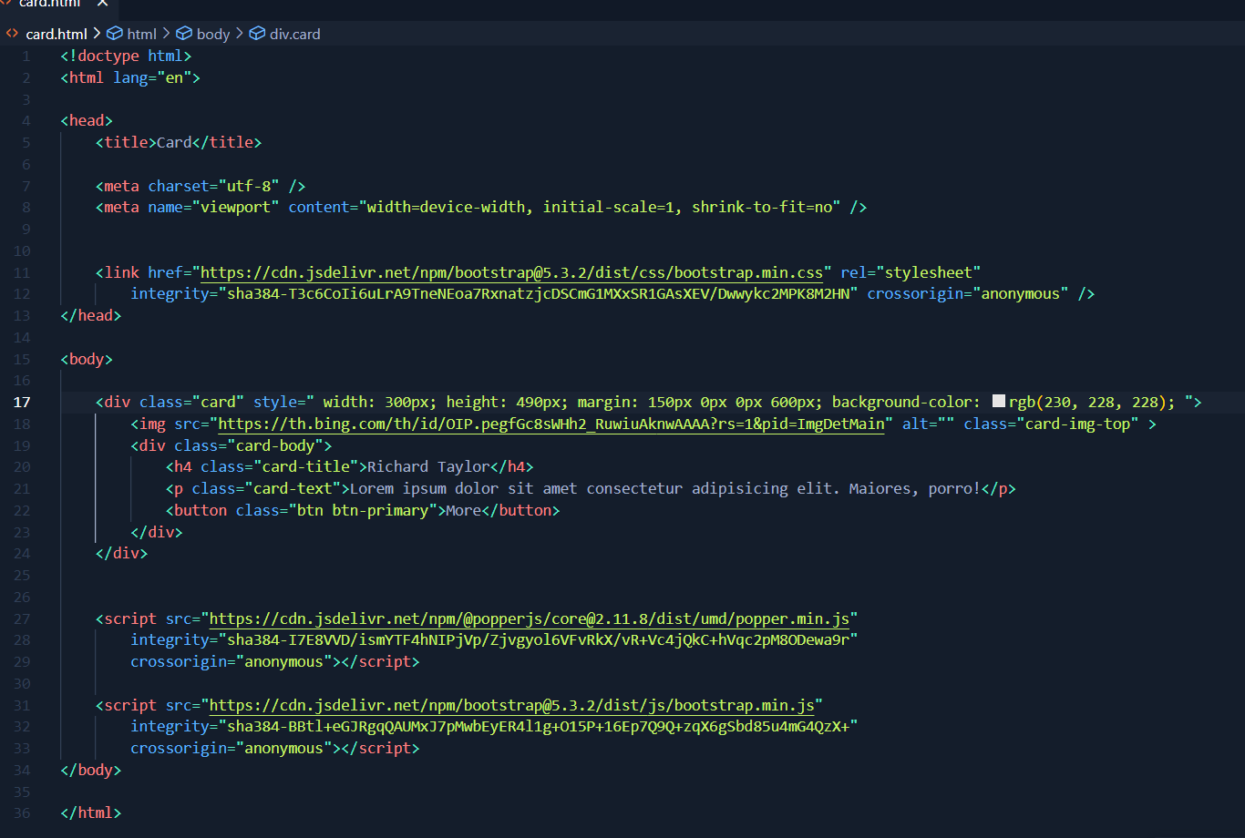

**[Code is given in github bootstrapp assignment folder ]**